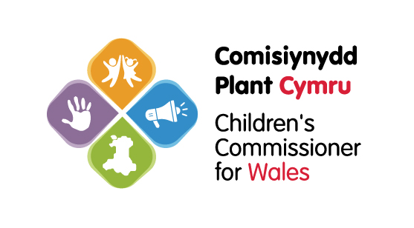
Equality and Diversity Monitoring Form
The Children’s Commissioner for Wales’ office looks at the equality and diversity of the people who apply for roles at our organisation.

This is a legal requirement under the Equality Act 2010.

We ask people who apply for roles at our organisation to fill out this form.

We can use the responses to the questions on this form to:

- Analyse whether we have a diverse range of people applying for the advisory panel
- Investigate any inequalities and their causes
- Work harder to make sure people from all backgrounds feel able to apply for our roles
We want to make sure everyone receives fair treatment and is protected from discrimination.

The information you give us is confidential and you do not have to share anything you do not want to. We do not ask for your name and the form is kept separate to your application.

This monitoring form has been designed taking into account guidance issued by the Office of National Statistics. This approach allows for consistency within Wales, enabling us to compare our data with other sources.
The information you provide on this form will be handled in the strictest confidence and held in accordance with the requirements of the Data Protection Act 1998.

We will only use this information for the purposes of statistical monitoring by a very limited number of authorised individuals.

If you have any concerns or questions, please contact us at recruitment@childcomwales.org.uk.

1. How would you describe your national identity?
Welsh ☐ English ☐ Scottish ☐ Northern Irish ☐ British ☐
I describe my national identity in another way (please describe) --------------------------------------
I prefer not to say ☐
2. How would you describe your ethnic origin?
Please choose one section, and then tick one box to describe your ethnic group or background
I would prefer not to disclose my ethnic origin 5
White ethnic origins:
White -Welsh 5 White – English 5 White- Irish 5 White –Northern Irish 5 White - Scottish 5
White - British 5 White - Roma 5 White Gypsy or Irish Traveller 5
Other - I prefer to describe my white ethnic origin as (please describe) ________________________
Asian and Asian British origins:
Asian - Indian 5 Asian -Pakistani 5 Asian –Bangladeshi 5 Asian Chinese 5
Other - I prefer to describe my Asian or Asian British origins as (please describe) __________________
Black/ African/Caribbean/Black British origins:
Black – African 5
Black – Caribbean 5
Other - I prefer to describe my Black or Black British origins as (please describe) _________________
Multiple or mixed ethnic origins:
Multiple - White and Black Caribbean 5
Multiple - White and Black African 5
Multiple - White and Asian 5
Other – I prefer to describe my multiple ethnic origin as (please describe) ________________________
Other ethnic groups:
Arabic 5
I prefer to describe my ethnic origin as (please describe) ___________________________

3. How would you describe your gender identity?
Male □ Female □ Trans □ (Trans is an umbrella term for people whose gender identity in some way differs from the gender they were assigned at birth).
I prefer to describe my gender identity in another way ..................................................................
4. What is your age range?
Under 20 □ 20-24 □ 25-29 □ 30 -34 □ 35-39 □ 40-44 □ 45-49 □ 50-54 □ 55-59 □
Over 60 □ Prefer not to say □

The Equality Act 2010 defines disability as a physical or mental impairment, which has a substantial and long-term adverse effect on a person’s ability to carry out day-to-day activities.
5. Do you consider yourself to have a disability?
Yes□ No□ Prefer not to disclose □
Please explain the impact of your disability on your day-to-day activities…………………………………………………..

6. What is your sexual orientation?
Bi sexual 5
Gay man 5
Gay woman /lesbian 5
Heterosexual 5
Prefer not to disclose 5
I prefer another description (please describe) …………………………

7. What is your religion or belief?
Atheist 5 Buddhist 5 Christian (all denominations) 5 Hindu 5 Humanist 5 Jewish 5 Muslim 5
No religion or belief 5 Sikh 5
Other religion or belief system (please describe) …………………………
Prefer not to disclose 5

8. Please note where you saw this post advertised.

Thank you for completing this form.

Please return this form to Amanda.Evans@childcomwales.org.uk marked Equality Monitoring Private and Confidential in the subject line.

